On April 28, 1968, a group of people decided to form a Society dedicated to the "preservation of historical data and artifacts of our community". The application was signed by eight persons on June 27, 1968. The Certificate of Incorporation was dated July 2nd, 1968 under the name “Sundre & District Historical Society”.
In the years following the formation of the Historical Society, there have been numerous changes and additions to the Museum. Several historic buildings have been moved onto the site, including the Bergen School, built in 1908, complete with bell, bell tower, and many original desks and books; the Pioneer Cabin, also from the Bergen area and built in 1913; The Ferryman's House, which originally stood at the Garrington Ferry Crossing; and the old Red Deer Ranger Station, which has been reconstructed and refinished, utilizing many of the original logs and artifacts. There is also a fully operational blacksmith shop; a barn set up with stalls, mangers and antique equipment.
Visit us today!

Hours of Operation
Summer Season:
May Long to October Long
Monday to Sunday 10am to 5 pm

Winter Season:
*Village Closed*
October Long to May Long
Monday to Sunday 10am to 5 pm

- Group tours
- School Programs
- Free Parking
- Fully Accessible
- Picnic Area
- Horseshoe Pits
- Sandbox for children
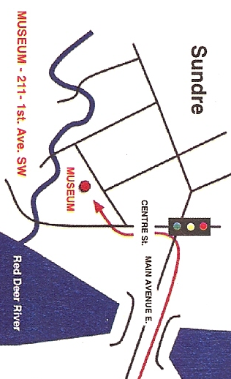
211 - 1st Ave SW Sundre, Alberta
Tel: 403-638-3233 Fax: 403-638-3295
Web: www.sundremuseum.com
Email: sundremuseum@telus.net

Sundre Pioneer Museum

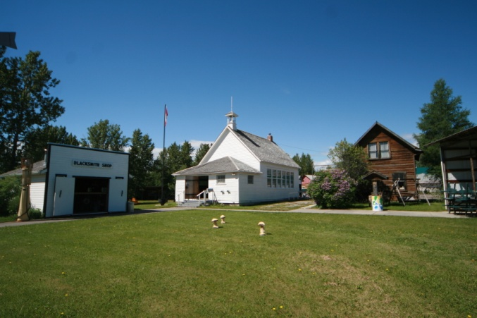

Featuring the Chester Mjolsness
World of Wildlife Exhibit

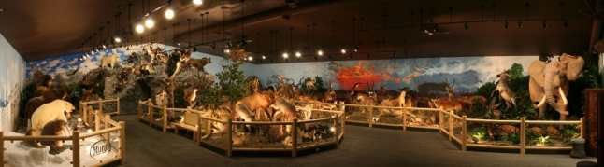

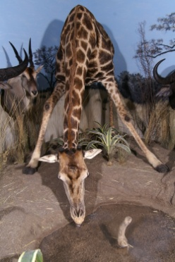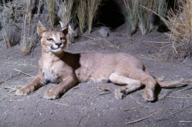

Sundre, Alberta
Sundre is a small town in the Red Deer River Valley just an hour’s drive North West of Calgary. It is a major service center for the area’s industry which includes Oil & Gas, lumber and forestry, ranching and farming, and wilderness tourism. Only 30 minutes from the Rocky Mountains and amazing places like the Ya Ha Tinda Ranch, Big Horn Falls, and Limestone Mountain. The Sundre area has many campgrounds, trails and open green spaces to visit as well as a thriving downtown core, K-12 school and hospital. There are many lakes, rivers and beautiful landscapes in the area, with a few of them housing the best fishing, golfing, and camping in Alberta. More information about the town of Sundre can be found at www.sundre.com.

Sundre & District Museum
The Sundre Museum is open 363 days a year; with Christmas Day and New Years Day being the exception. It is run by a volunteer board of directors, a paid executive director, and many dedicated volunteers.

The Pioneer Village closes during the winter months but opens up May Long weekend until Thanksgiving Weekend. **Please note hours may change due to weather; we encourage everyone to contact the office prior to booking their visit. Group rates and special tours can be arranged. Contact the museum director at 403-638-3233 or visit our website for more information www.sundremuseum.com

The Museum Experience
The Pioneer Village sits on 4 acres of land and features 8 heritage buildings. The Niels Eskesen Reception Centre is our main admission entrance and houses the Pioneer Gallery and Chester Mjolsness World of Wildlife Exhibit which are sure to keep you and your family engaged. With membership’s available providing year-round access, general store discounts, and reasonable admission rates, there is much to see and enjoy. Come #EXPLOREsundre and celebrate “The Way We Were” at the Sundre Pioneer Museum.

Pioneer Gallery
The main Reception Center houses the Museum’s collection of Aboriginal and Pioneer artifacts. It has many of the day-to-day items used in the early part of the 20th century, and items that were important to the daily life of the people in the Sundre area. From Cowboy to Doctors, lumber camps to spinning wheels, the Sundre Museum has a sample of everything. Occasionally the Museum displays traveling exhibits from other Museums. Call for the latest information.

Pioneer Village
The Pioneer Village sits on 4 acres of land and has eight heritage buildings along with a stage, horseshoe pits and sandbox. The Village opens in the summer and is a central location for local and non-locals to celebrate community events like; weddings, birthday parties and other social gatherings. We are thrilled to have a number of heritage performers donate their time and talents to us, so we can better understand “The Way We Were”. Please check our website for event details.

World of Wildlife
This exhibit pays homage to a local resident of Sundre, Chester Mjolsness, who grew up in Sundre and started a successful lumber business. In 1986, six years after Chester retired, he took up big game hunting. Come visit us as we showcase the 170 mounts acquired over a number of years through a variety of experiences. Come see what Calgary and Edmonton were desperate to obtain but didn’t; because one man wanted to bring this treasure back to a place where it belonged. The collection is set in a natural and beautifully painted room where the art of paint and taxidermy can be appreciated.

